**Curriculum Vitae**

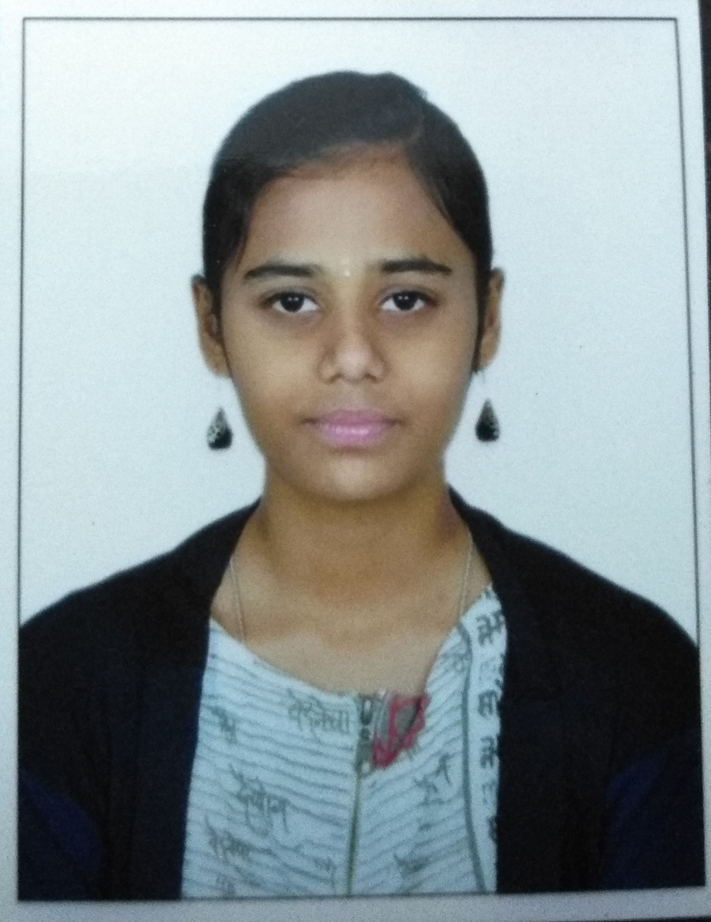

Name : Lohitha SP

Working at HCL Technology

Designation : Software Engineer

Experience : 2.5 years

Location : Bangalore

**Profile**

**Professional Objective:**

To work in a firm with a professional work driven environment, where I can learn new things and apply my knowledge, skills which would enable me as a fresh graduate while fulfilling organizational goals.

**Professional Summary:**

TechBee with 2 years of experience in Mechanical Domain. Design & Engineering drawing, Details about Material science, Applied mechanics, GD&T, Engineering mechanics, Kinematics, Strength of materials.

**Tools:**

* MS office,
* Solidworks,
* Adobe Photoshop,
* Creo

**Work Experience:**

HCL Technologies, 04-Nov-2020

Total Experience: **2.5 years**

Band: E1

Sub Band: E1.1

**Project name: KDP, IGEN**

Experience: 1.5 year

* Working as a Software Engineer under the guidance of PM.
* Currently working at Photoshop, Teardown, Documentation, MS Office.

**Project name: Accessibility Testing**

Experience: 8 months

**Core Qualification:**

* Knowledge in Research and developing sector.
* Knowledge in Photoshop, Solidworks.
* Basic Knowledge in Geometric dimension and Tolerance (GD&T).

**Personal Traits:**

* Have a capability to quick understand the purpose of work.
* Creative Thinking for my interesting work.
* Enthusiastic, Competitive and responsible person.
* Efficient oral and verbal communication.

**Academic Research:**

* Project done on Agriculture vehicle. (Diploma project).
* Developed an agriculture vehicle with PIC controller instead of Arduino.

**Education:**

|  |  |  |  |
| --- | --- | --- | --- |
| **Scholastic chronicle: YEAR** | **COURSE** | **BOARD / UNIVERSITY** | **PERCENTAGE** |
| Pursuing | BCA | Sastra University | - |
| 2020 | Diploma in Mechanics | TSS | 84% |
| 2019 | H.S.C | State board | 75% |
| 2017 | S.S.L.C | State board | 94% |

**Personal Details:**

Name : Lohitha SP

Father’s Name : Prakasam V

Gender : Female

Date of Birth : 19-Feb-2002

Linguistic Abilities : Tamil, English.

Nationality : Indian

Hobbies : Listening music, Social awareness

Special Skills : Photoshop, MS Office, Documentation

Learning new things related to my work.

Preferred location : Bangalore.

**Declaration:**

I hereby declare that all the details furnished above are true to the best of my knowledge. If I am get an opportunity, I will stain my every nerve to add value to your organization.

Place: Namakkal

